Database systems Project

University Database system

CSE 333

Mahmoud Mourad Youssef 18P6555

Mohamed Sayed Awwad 18P7298

Mohamed Ashraf Fathy 18P5993

Nour El-Din Mohamed Hisham 18P5806

Andrew Saied Labib 18P5886

Safia Medhat Abdul-Aziz Elsayed 18P7367

# Task 1: Introduction

For our sample database application, consider a university database that keeps track of students and their majors and registration as well as of the university’s course offerings. For each person, the database maintains information on the person’s Name, Social Security number, address, sex, and birthdate. Person can be either employer or student. Employer that has a salary, ID and office number can be staff with office name, teacher assistant that has courses to teach or instructor that advises and teaches courses. All employers are related to the department with which they work there and can be associated with several departments. Every student has an ID whatever he is graduated or not. Each undergrad student is also related to his major departments. He also takes courses with specific course code and name. Every student has an advisor with certain advising hours.

# Task2: Important data and reports

Person: name, social number, address, sex, birthdate.

Employer: employer id, salary, office number

Student: ID

Staff: office name

Teacher assistant: courses they teach

Instructors: rank

Grad student: graduation GPA

Under graduation student: level

Department: department name, department phone

College: college name, college number

Course: course name, course code, course description

Reports:

1. Get the names of the students who take the analysis course

2. Select every course that have name “analysis” in its name

3. Select all courses that instructor “Hisham” teaches gives with his rank

4. Select the name of the grad students with GPA more than or equals 3

5. Select students who take “programming” course and print the names and ids

# Task3: Assumptions

1) Assume the department has a name and number.

2) Assume the college has a name and number.

3) Assume every course has a description.

4) a person is an employee or a student.

5) student must take a course.

6) student must be advised by one of the instructors.

7) the TA must teach at least one course.

8) the employees are either TA, instructors, Staffs.

9) the students are either under graduates or graduates.

10) the departments must belong to a certain college.

11) the instructors and TA’s must work for at least one department.

12) each department has number of courses.

13) the instructors must be assigned to at least one course.

14) each student must enroll into a department to major.

15) the department has multiple courses to offer the students.

# Task4:

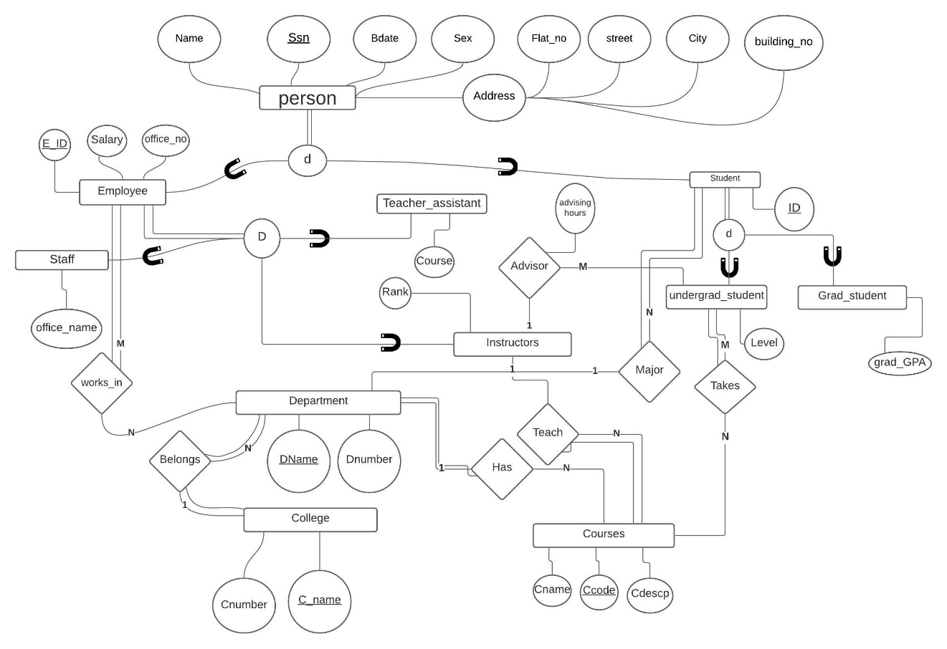

# Task5:

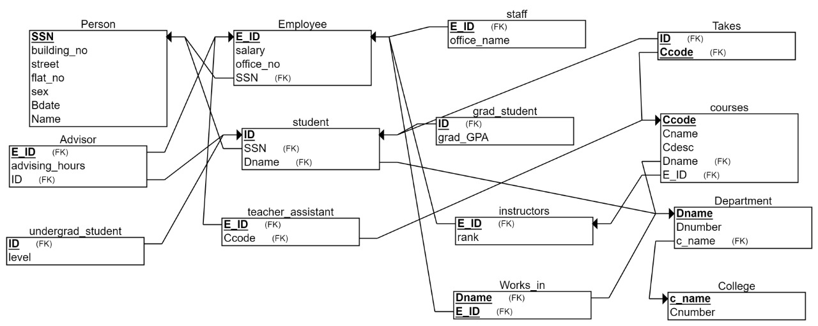

# Task6: using PHP for examples.

## Creating Tables:

CREATE TABLE Person

(

building_no INT NOT NULL,

street VARCHAR(20) NOT NULL,

flat_no INT NOT NULL,

sex CHAR(10) NOT NULL,

Bdate DATE NOT NULL,

Name VARCHAR(10) NOT NULL,

SSN INT NOT NULL,

PRIMARY KEY (SSN)

);

CREATE TABLE Employee

(

E_ID INT NOT NULL,

salary INT NOT NULL,

office_no INT NOT NULL,

SSN INT NOT NULL,

PRIMARY KEY (E_ID),

FOREIGN KEY (SSN) REFERENCES Person(SSN)

);

CREATE TABLE instructors

(

rank CHAR(10) NOT NULL,

E_ID INT NOT NULL,

PRIMARY KEY (E_ID),

FOREIGN KEY (E_ID) REFERENCES Employee(E_ID)

);

CREATE TABLE College

(

c_name VARCHAR(20) NOT NULL,

Cnumber INT NOT NULL,

PRIMARY KEY (c_name)

);

CREATE TABLE staff

(

office_name VARCHAR(20) NOT NULL,

E_ID INT NOT NULL,

PRIMARY KEY (E_ID),

FOREIGN KEY (E_ID) REFERENCES Employee(E_ID)

);

CREATE TABLE Department

(

Dname VARCHAR(20) NOT NULL,

Dnumber INT NOT NULL,

c_name VARCHAR(20) NOT NULL,

PRIMARY KEY (Dname),

FOREIGN KEY (c_name) REFERENCES College(c_name)

);

CREATE TABLE Works_in

(

Dname VARCHAR(20) NOT NULL,

E_ID INT NOT NULL,

PRIMARY KEY (Dname, E_ID),

FOREIGN KEY (Dname) REFERENCES Department(Dname),

FOREIGN KEY (E_ID) REFERENCES Employee(E_ID)

);

CREATE TABLE student

(

ID INT NOT NULL,

SSN INT NOT NULL,

Dname VARCHAR(20) NOT NULL,

PRIMARY KEY (ID),

FOREIGN KEY (SSN) REFERENCES Person(SSN),

FOREIGN KEY (Dname) REFERENCES Department(Dname)

);

CREATE TABLE grad_student

(

grad_GPA FLOAT NOT NULL,

ID INT NOT NULL,

PRIMARY KEY (ID),

FOREIGN KEY (ID) REFERENCES student(ID)

);

CREATE TABLE courses

(

Ccode VARCHAR(20) NOT NULL,

Cname VARCHAR(20) NOT NULL,

Cdesc INT NOT NULL,

Dname VARCHAR(20) NOT NULL,

E_ID INT NOT NULL,

PRIMARY KEY (Ccode),

FOREIGN KEY (Dname) REFERENCES Department(Dname),

FOREIGN KEY (E_ID) REFERENCES instructors(E_ID)

);

CREATE TABLE Takes

(

ID INT NOT NULL,

Ccode VARCHAR(20) NOT NULL,

PRIMARY KEY (ID, Ccode),

FOREIGN KEY (ID) REFERENCES student(ID),

FOREIGN KEY (Ccode) REFERENCES courses(Ccode)

);

CREATE TABLE teacher_assistant

(

E_ID INT NOT NULL,

Ccode VARCHAR(20) NOT NULL,

PRIMARY KEY (E_ID),

FOREIGN KEY (E_ID) REFERENCES Employee(E_ID),

FOREIGN KEY (Ccode) REFERENCES courses(Ccode)

);

CREATE TABLE undergrad_student

(

level INT NOT NULL,

ID INT NOT NULL,

PRIMARY KEY (ID),

FOREIGN KEY (ID) REFERENCES student(ID)

);

CREATE TABLE Advisor

(

advising_hours INT NOT NULL,

ID INT NOT NULL,

E_ID INT NOT NULL,

PRIMARY KEY (E_ID),

FOREIGN KEY (ID) REFERENCES student(ID),

FOREIGN KEY (E_ID) REFERENCES Employee(E_ID)

);

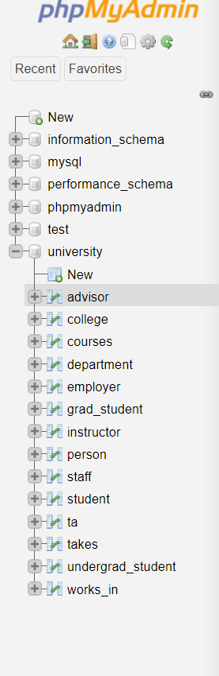

## Inserting Reports:

Inserting some Persons, in order first enter the person’s SSN, then person’s Name, then person’s Birthdate, then person’s sex, then person’s Address by a certain format starting by his flat number then his street name the the city at last the building number.

Some Samples:

INSERT INTO `person` (`ssn`, `Name`, `Bdate`, `Sex`, `Flat_NO`, `Street`, `City`, `Building_NO`) VALUES ('111', 'Ahmed', '2000-06-14', 'Male', '3', '23 Mostafa', 'Cairo', '1'), ('222', 'Mohamed', '2000-07-27', 'Male', '7', '6 Maadi', 'Cairo', '23');

INSERT INTO `person` (`ssn`, `Name`, `Bdate`, `Sex`, `Flat_NO`, `Street`, `City`, `Building_NO`) VALUES ('333', 'Sara', '2000-01-25', 'Female', '4', '17 New Cairo', 'Cairo', '6'), ('444', 'Zeina', '2000-10-28', 'Female', '10', '44 Nasr City', 'Cairo', '15');

INSERT INTO `person` (`ssn`, `Name`, `Bdate`, `Sex`, `Flat_NO`, `Street`, `City`, `Building_NO`) VALUES ('555', 'Yassin', '2000-04-01', 'Male', '9', '23 Nasr City', 'Cairo', '20'), ('666', 'Omar', '2000-09-20', 'Male', '16', '6-1 zamalek', 'Cairo', '18');

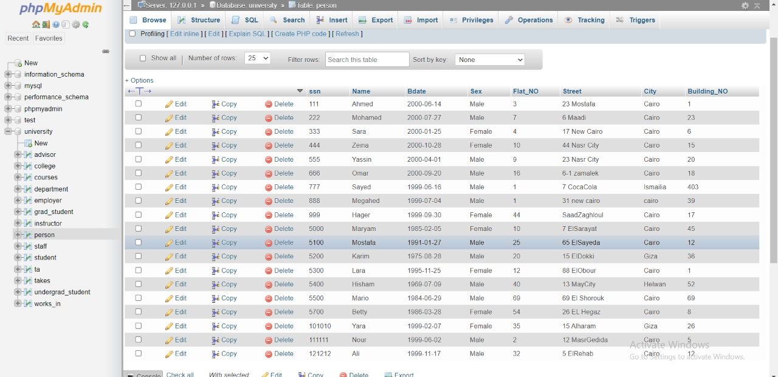

## Making Reports:

1. Selecting all students that takes the Graphic Analysis course

SELECT person.Name, takes.ID, courses.CCode

FROM courses, takes, student, person

WHERE takes.CCode=courses.CCode AND takes.ID=student.ID AND student.ssn=person.ssn AND Cname='Graphic Analysis'

1. Select every course that contains the word “Analysis” in the Cname.

SELECT CCode, Cname

FROM courses

WHERE Cname like '%Analysis%'

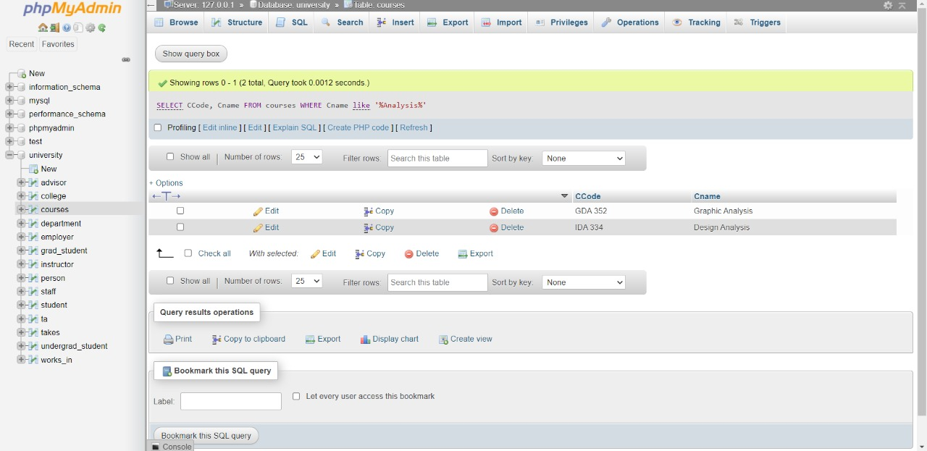

1. Selecting all the courses that instructor “Hisham” gives with his rank.

SELECT instructor.E_ID, rank,courses.CCode

FROM courses,instructor,person,employer

WHERE courses.E_ID=instructor.E_ID AND

instructor.E_ID = employer.E_ID AND

employer.ssn=person.ssn AND

person.name='Hisham'

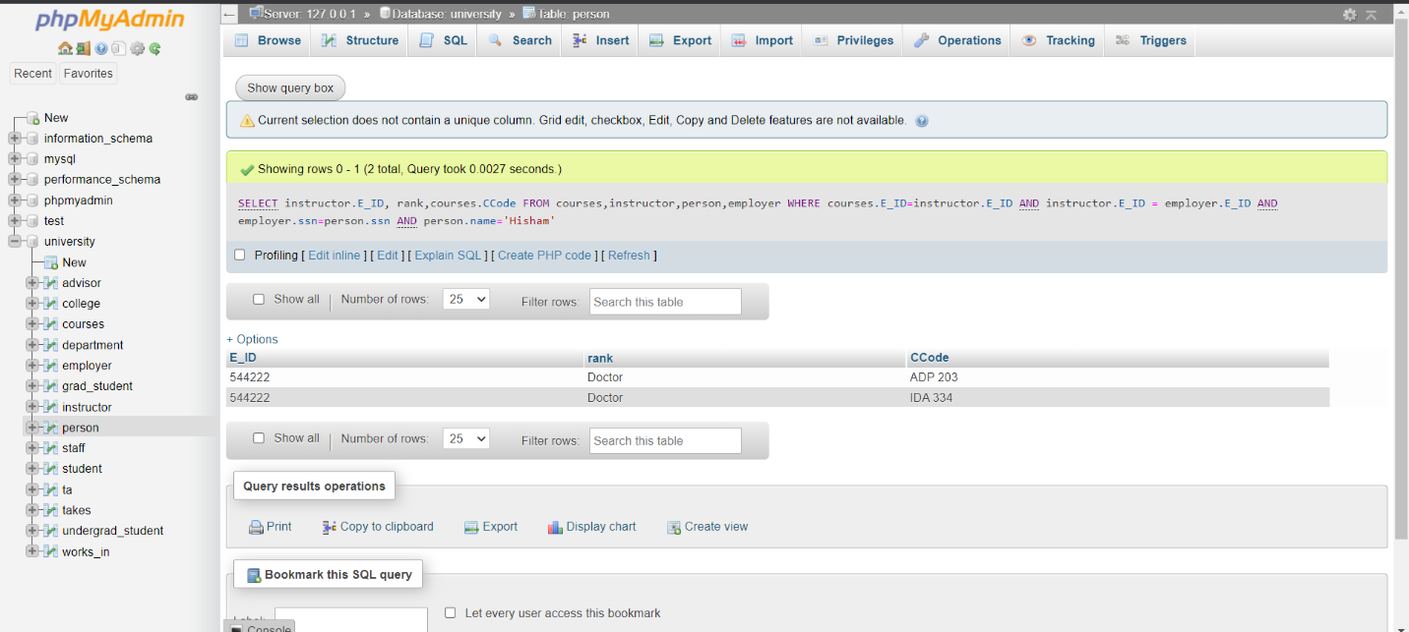

1. Selecting the name of the grad students where their GPA is more than or equal 3.0

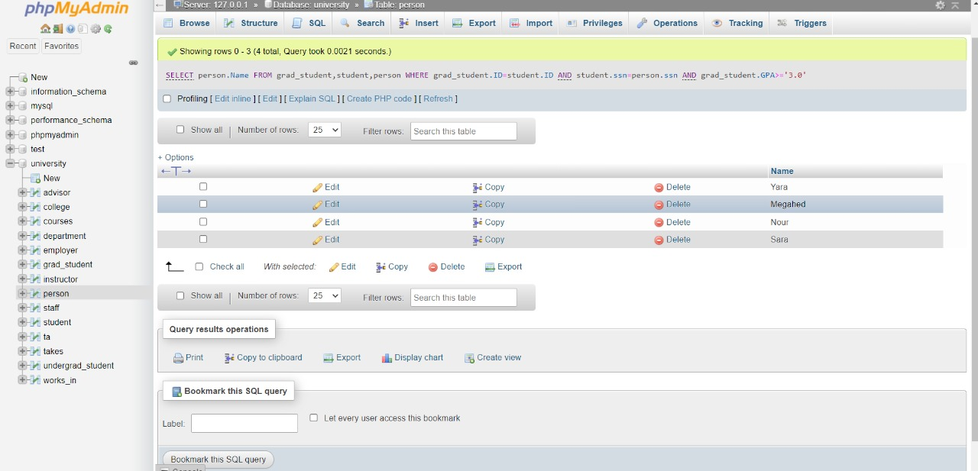SELECT person.Name

FROM grad_student,student,person

WHERE grad_student.ID=student.ID AND student.ssn=person.ssn AND grad_student.GPA>='3.0'

1. Selecting the students to know how many students take the course “programming” and print their names and IDs.

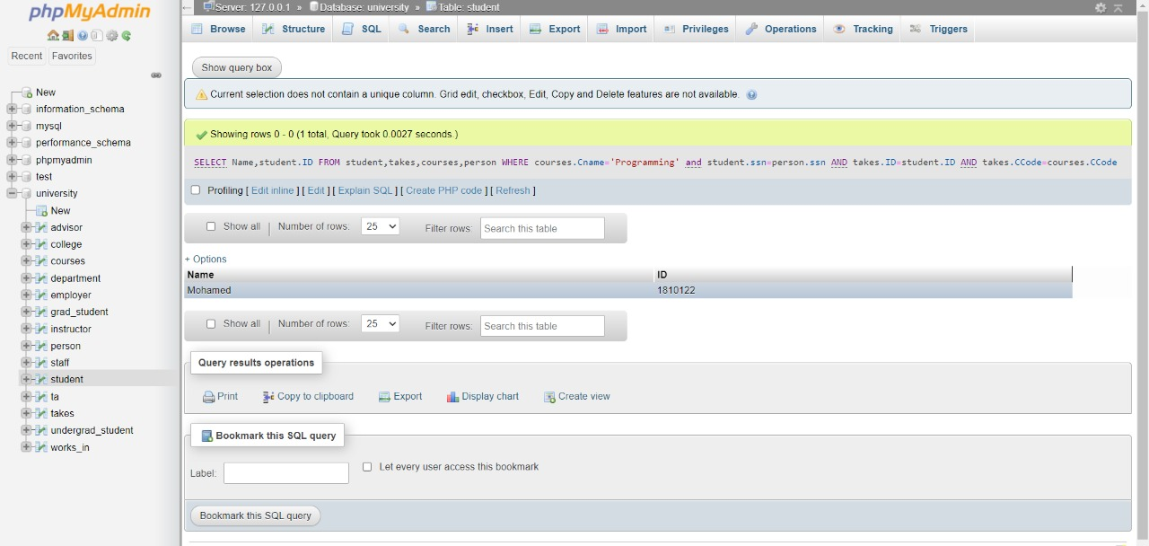

## Updating Reports

1. 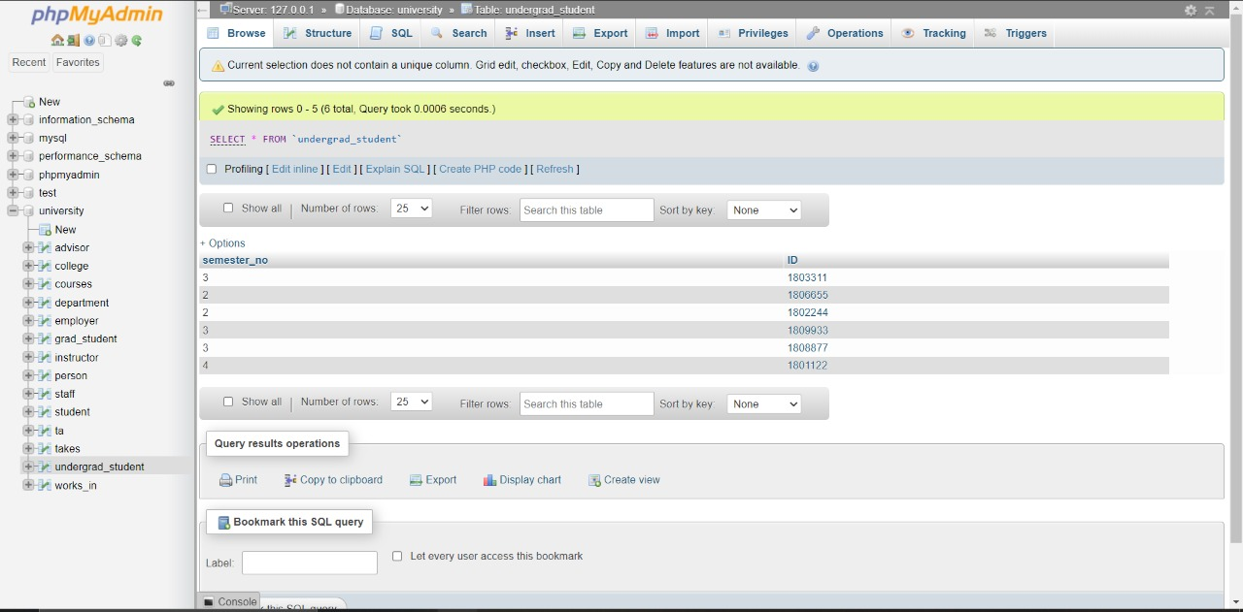updating the semester number from 3 to 4 whose ID is 1801122  
   UPDATE undergrad_student SET semester_no=semester_no+1 WHERE ID=1801122

1. Updating the student ID from 1801122 to 1810122

UPDATE student SET ID=1810122 where ID=1801122

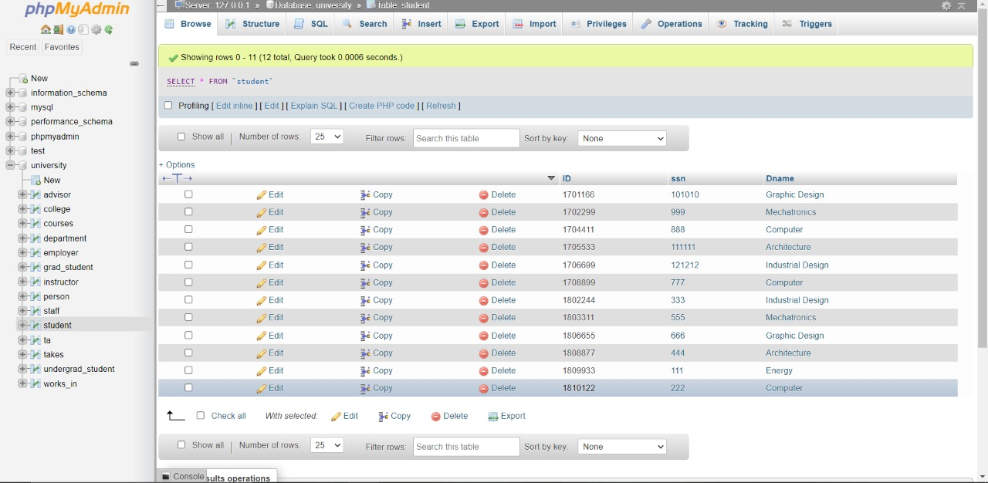

## Deleting Reports

1. Deleting an undergrad student where his ID is 1801122

DELETE FROM undergrad_student WHERE ID=1801122

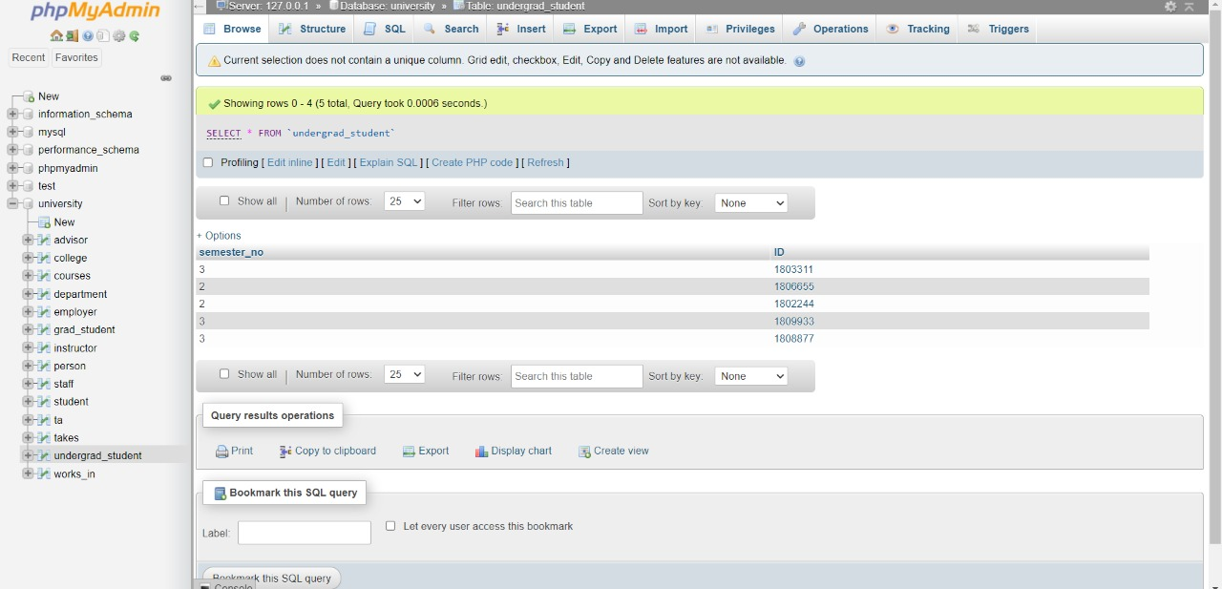

1. 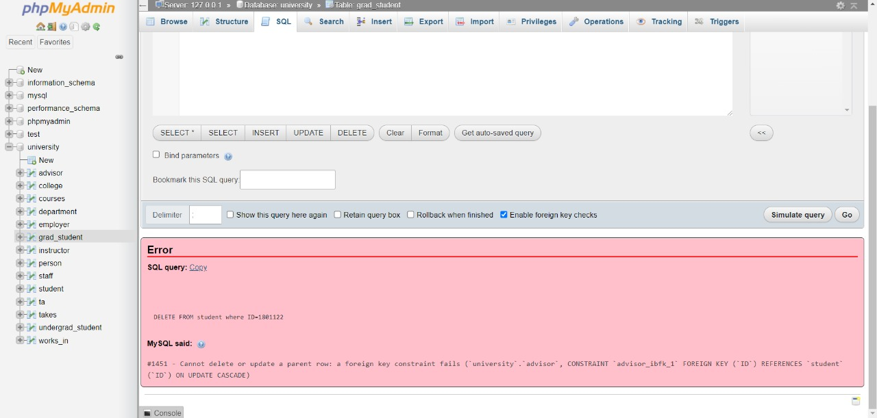we tried to delete the student whose ID is 1801122, because the ID was a primary key in student and the foreign key was on restrict the system refused to delete the student.

# Task 7:

## 7.1 ERD PLUS:

ERDPlus is a web-based database modelling tool that allows you to construct databases quickly and efficiently. Diagrams of Entity Relationships (ERDs) Schemas of Relationships (Relational Diagrams) Schemas with a Star (Dimensional Models.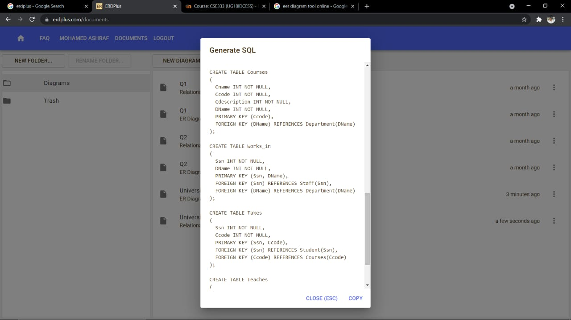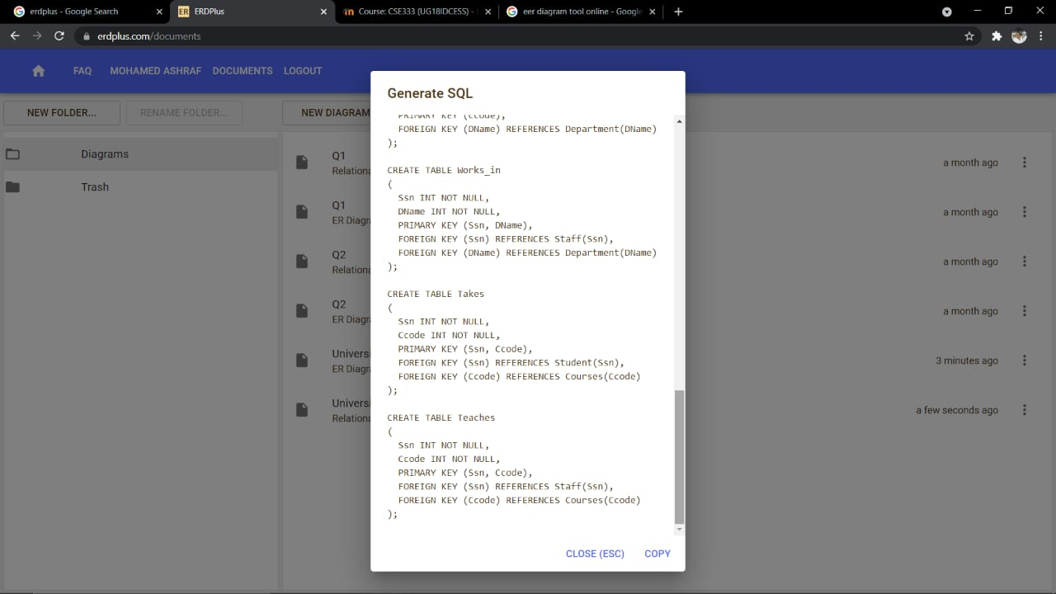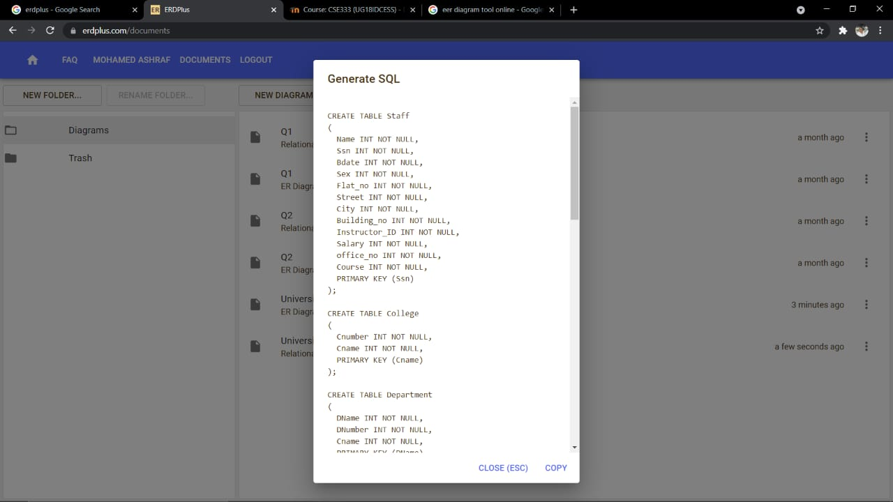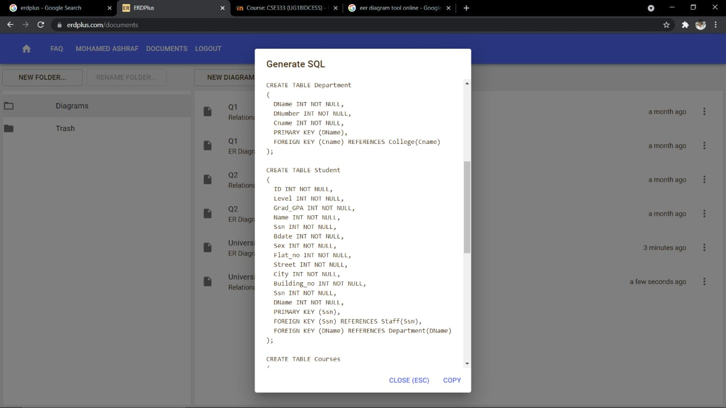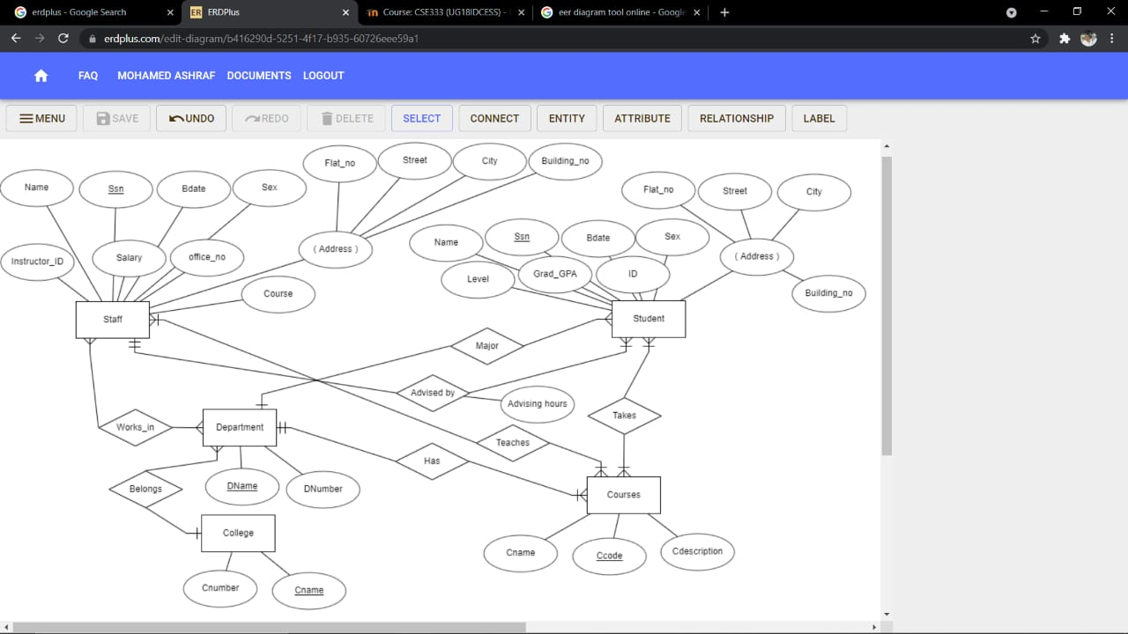

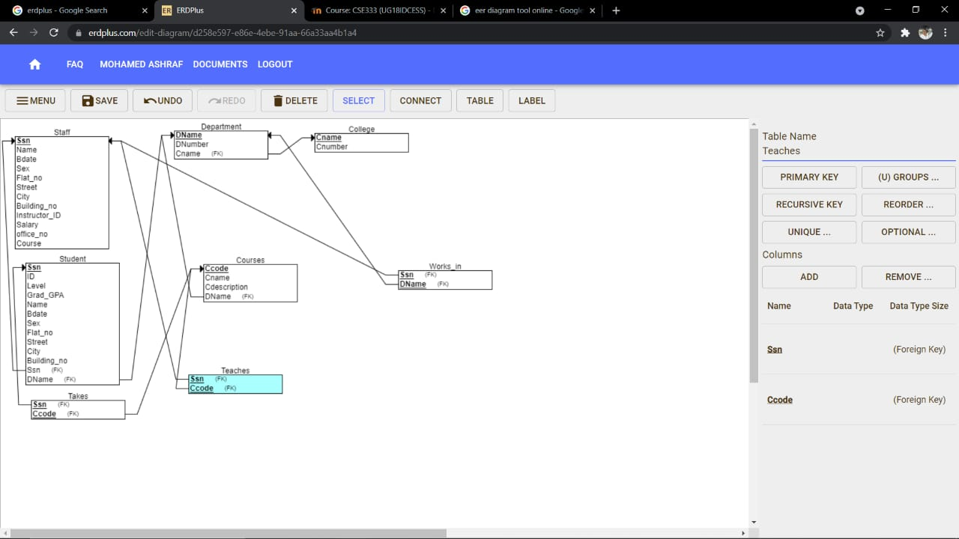

## 7.2 PhpMyAdmin

My SQL tool is php my admin we used it to create the database for the university system.

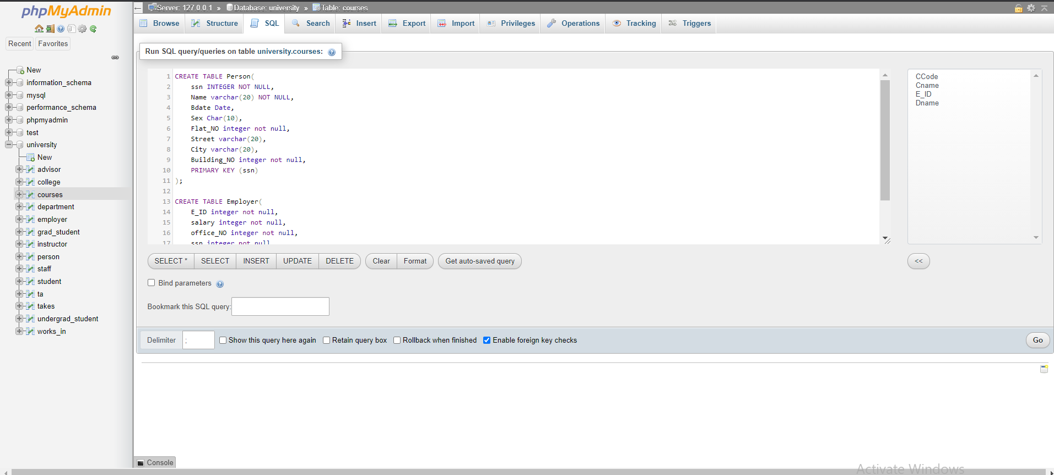Creating tables on php my admin:

Inserting in PHP my admin:

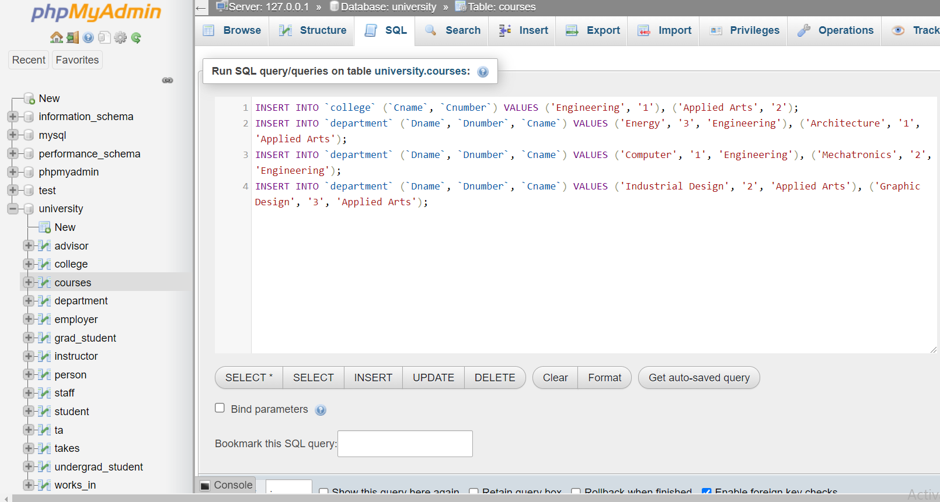

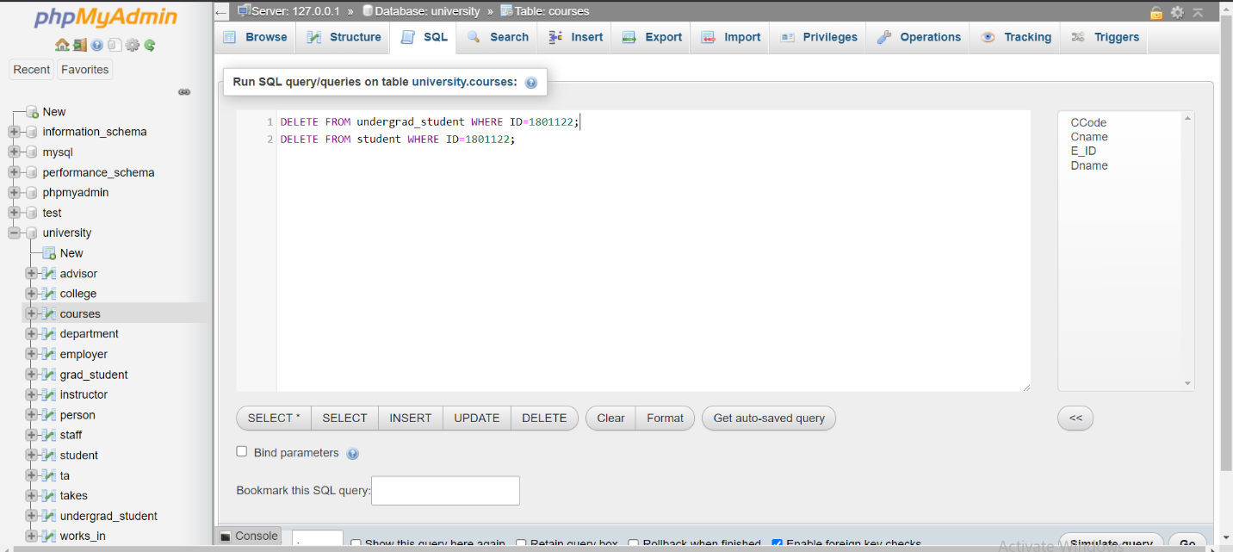Deleting in PHP my admin:

Updating in PHP my admin:

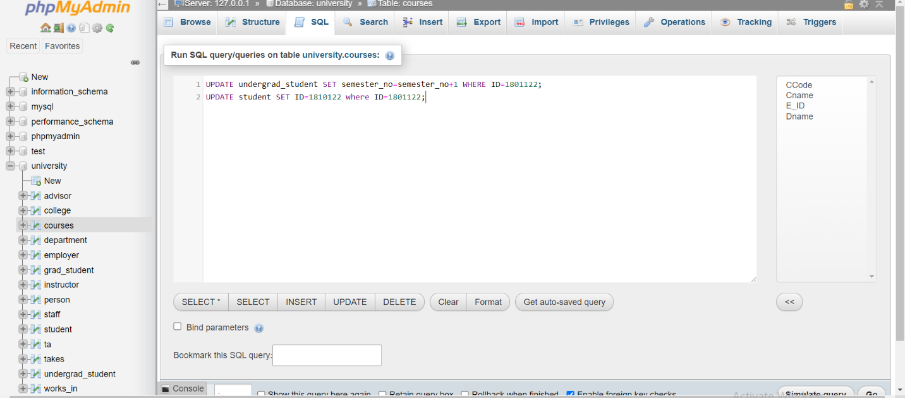

Selecting in PHP my admin:

